

**Let’s work on our Projects!!**

The goal of your WOW project is to find 3-5 interesting facts based on the Music and Movie Preference data and to display them with cool visualizations!

Here is a step-by-step guide on how to do your WOW project. You will download data from Ms. Shapiro’s friends on what their music and movie preferences are. Then you will use AzureML and visualization tools to come up with AWESOME results!

# **Here’s what to do:**

1. Break into groups as determined by Mr. Baxter.
2. Get ChromeBooks for your group to work on.
3. Go to [**aka.ms/rsadata**](http://aka.ms/rsadata)to get the dataset and **press download.**

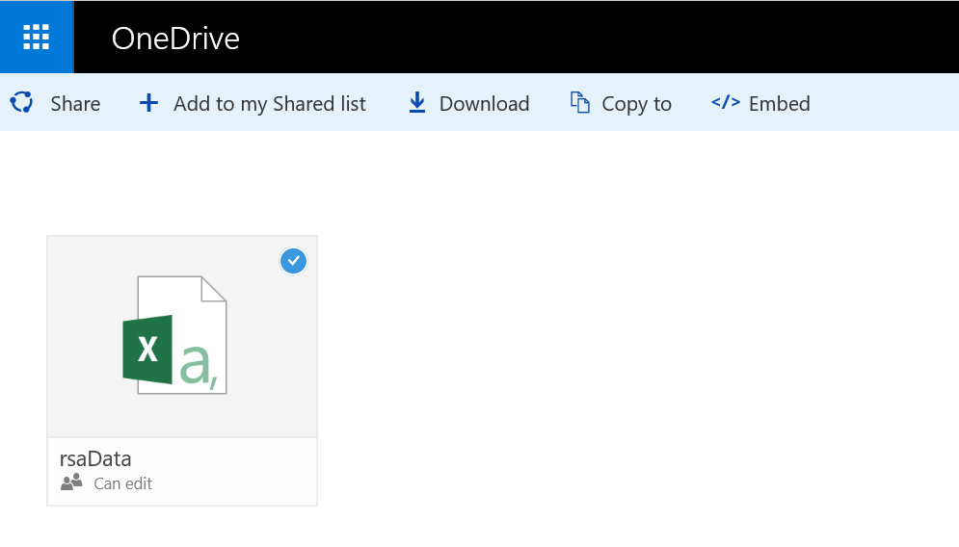



1. Go to [**https://studio.azureml.net/#**](https://studio.azureml.net/)
2. Press **“Get Started”**
3. Press **“Sign in”** and sign in with your accounts.

*## Ask Mr. Baxter for help if you don’t remember your emails and passwords.*

1. If the option to take a tour pops up, press **“Not Now”.** Otherwise move onto the next step.

## **Let’s Add the Data!**

1. Machine generated alternative text:
   NEW 
   DATASET 
   MODULE 
   EXPERIMENT 
   NOTEBOOK 
   PREVIEW 
   FROM 
   LOCAL FILE 
   Upload a new dataset from a local file Press **“New”** 🡺Click “**dataset”**🡺Click “**From local file”**





1. 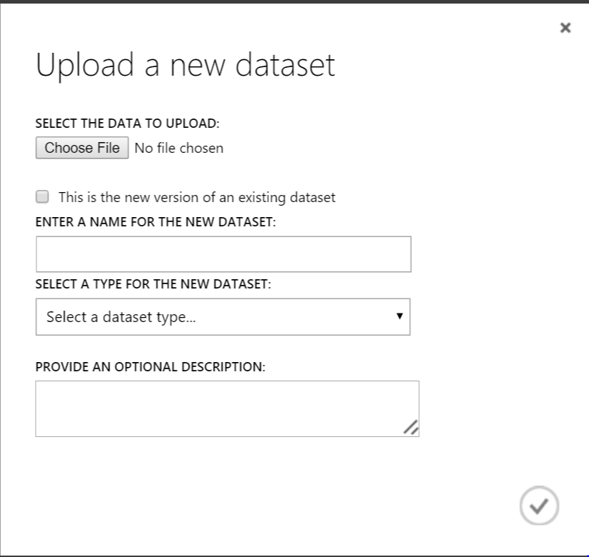Click “**choose file”🡺**Upload the data file.



1. The file should be in your Downloads folder and is called **“rsaData”**. 🡺 Click the check mark
2. 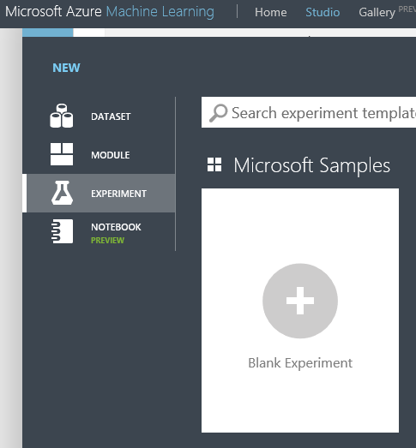Now let’s open up a new experiment. Press **new** 🡺**experiment** 🡺 Click on **blank experiment**
3. On the toolbar on the side, open up the **“Saved Datasets”** tab.
4. Click **“My Datasets”**
5. Drag **“rsaData.csv”** into the middle of the experiment.
6. Right click the box that you just pulled in and scroll over **“dataset”.** Click **visualize**.
7. Look at how many rows and columns there are.

## http://images.clipartof.com/thumbnails/1059215-Royalty-Free-Vector-Clip-Art-Illustration-Of-A-Stop-Sign-Character-Holding-A-Sign.jpg

## **STOP! ANSWER THESE QUESTIONS:**

* How many people took the survey? (*Hint: how many rows are there?)* __________________
* How many questions were they asked? (*Hint: how many columns are there?)* ________________
* Click on the different columns and look at the **Statistics** and **Visualizations** for each column. Name two findings that you see (i.e. how many males vs females took the survey, or what is the average number of hours per week that the subjects listened to)







* Click on a column and look at the visualization tab on the right. Choose a column and compare it to another column. For instance, find out the average number of hours of music that females listen to. Give an example of something you found.